

DLD Lab-04

Karnaugh Map



NATIONAL UNIVERSTIY OF COMPUTER AND EMERGING SCIENCES, FAST- Peshawar Campus

Department Of Computer Science

Instructor: Engr. Waseem Ullah

EL1005 – Digital Logic Design-Lab

SEMESTER SPRING 2022

Contents

1. Objectives: 2

2. Outcomes : 2

3. Equipment Required: 2

1- Simplification of 3 variable Boolean function using Kmap 2

1. Min term(product) 3

2. Max term(SUM) 4

3. Min Term & Max term 4

4. Sum of Product (Min Term) 5

5. Product of Sum (Max term) 6

6. Karnaugh Map 8

7. Lab Task 13

# Objectives:

3/4 variable Boolean function simplification using K-map in SOP (sum of products) and POS (product of sums ) forms

Implementation of simplified expressions using AND, OR and NOT gates

Implementation of simplified expressions using NAND and NOR gates

# Outcomes:

Students should be able to

Simplify, implement and verify 3/4 variable Boolean expressions in SOP and POS forms,

and using only NAND and only NOR gates.

# Equipment Required:

* DEV-2765E Trainer Board/ Multisim 14.2 /Logic.ly
* 7404 hex NOT (Inverter) gate IC
* 7408 quad 2-input AND gate IC
* 7432 quad 2-input OR gate IC
* 7400 quad 2-input NAND gate ICs
* 7402 quad 2-input NOR gate ICs
* Multisim / Logicly

# Simplification of 3 variable Boolean function using Kmap

In the lab there are 2 ACs and a door . There is a monitoring room as well . If any of the AC is on , AND the door is open ( i.e logic one for the door ) , then an output signal (i.e logic 1 ) is issued to the monitoring room , otherwise output remains zero .

Make a truth table corresponding to the above scenario, use A1 and A2 for ACs and D for door and S for output signal , simplify the Boolean function into

(a) sum-of-products form and (b) product-of-sums form

# Min term(product)

Minterm is product of boolean variables either in normal form or complemented form. In Minterm, we look for the functions where the output results in “1”

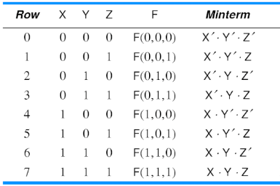

# Max term(SUM)

Maxterm is sum of boolean variables either in normal form or complemented form. In Maxterm we look for function where the output results in “0”

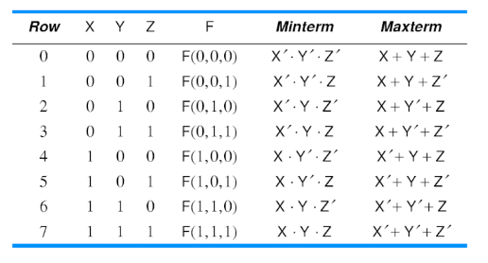

# Min Term & Max term

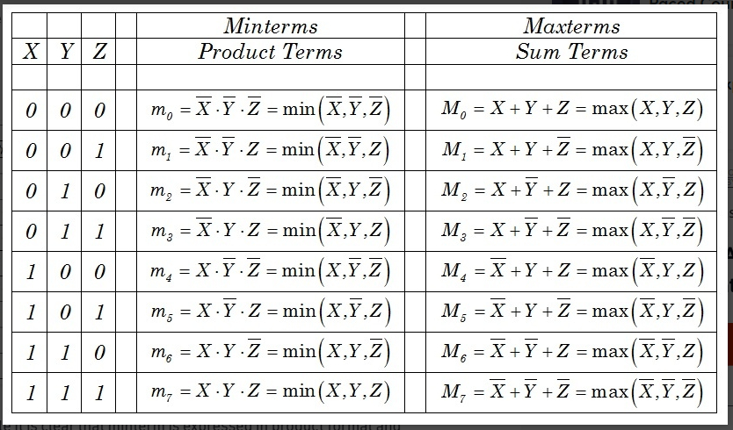

# Sum of Product (Min Term)

The SOP (Sum of Product) is the methods for deducing a particular logic function. Conversely, SOP produces a logical expression comprised of the OR of the multiple AND terms

A Sum-Of-Products Boolean expression is exactly a set of Boolean terms added together, each term being a product of a combination of Boolean variables. To get the Sum of Products form from a truth table, OR together all of the min terms which has a value of 1.

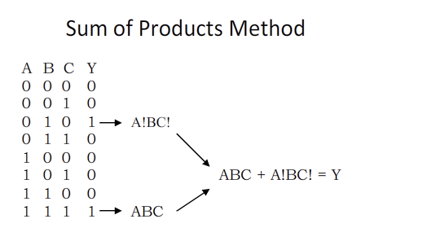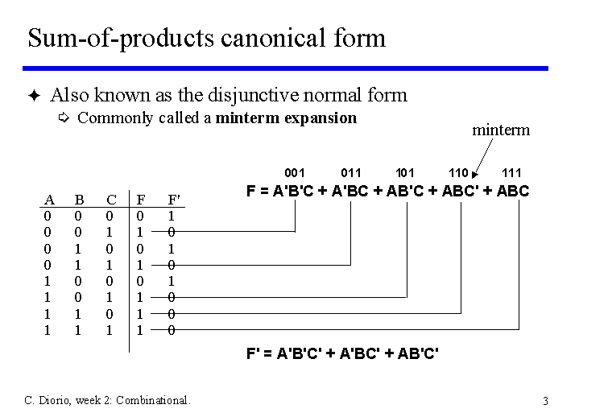

# Product of Sum (Max term)

The POS (Product of Sum) is the methods for deducing a particular logic function. Conversely, POS produces a logical expression comprised of the AND of the multiple OR terms

A Product of Sum Boolean expression is exactly a set of Boolean terms product together, each term being a added of a combination of Boolean variables. To get the Product of Sum form from a truth table, product together all of the max terms which has a value of 0.

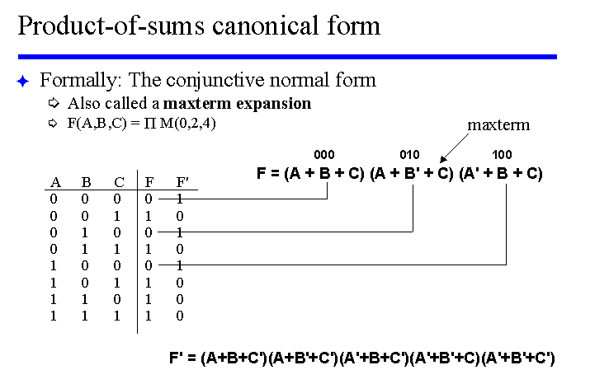

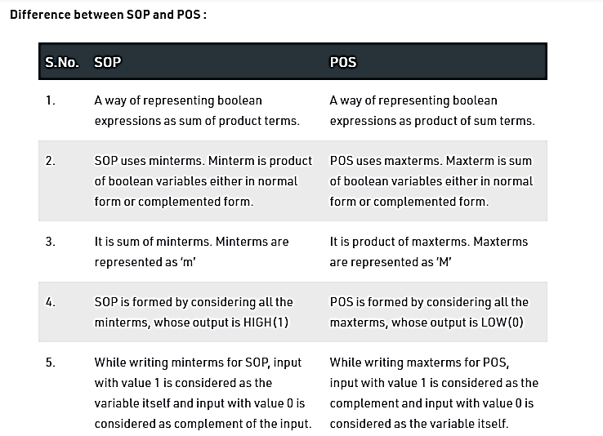

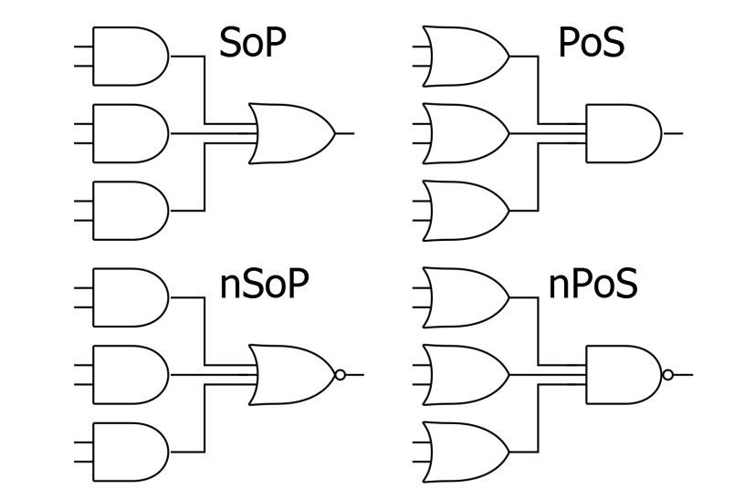

# Karnaugh Map

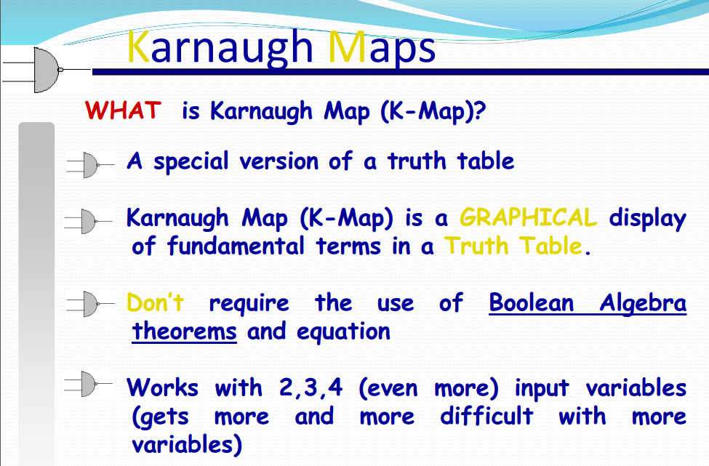 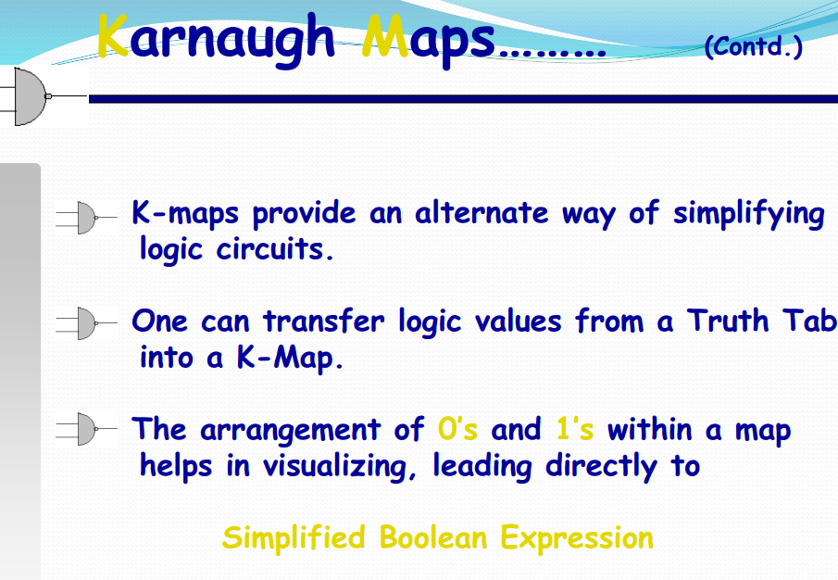

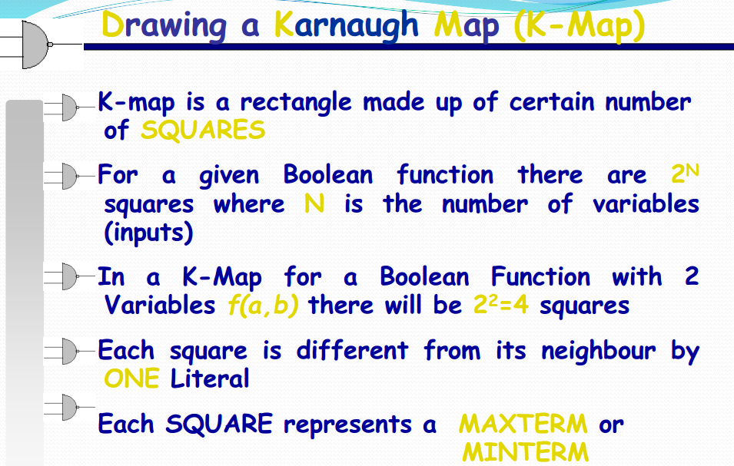

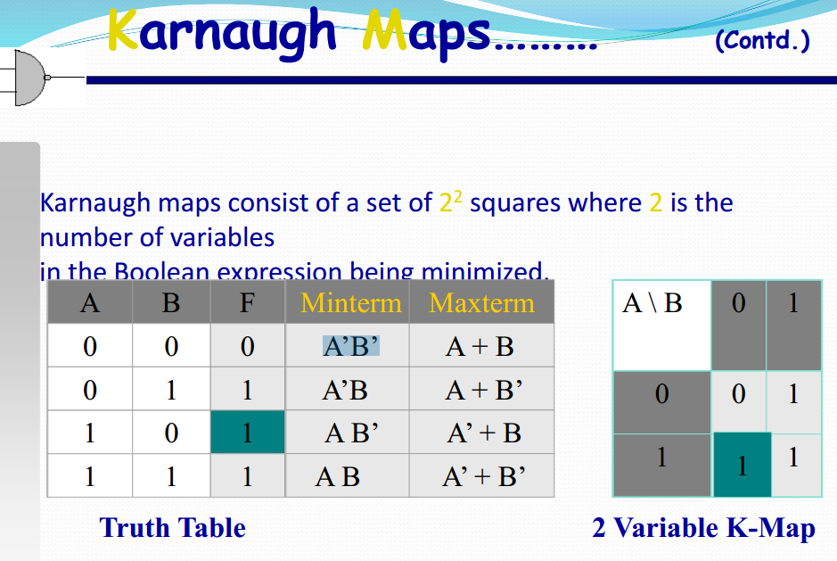

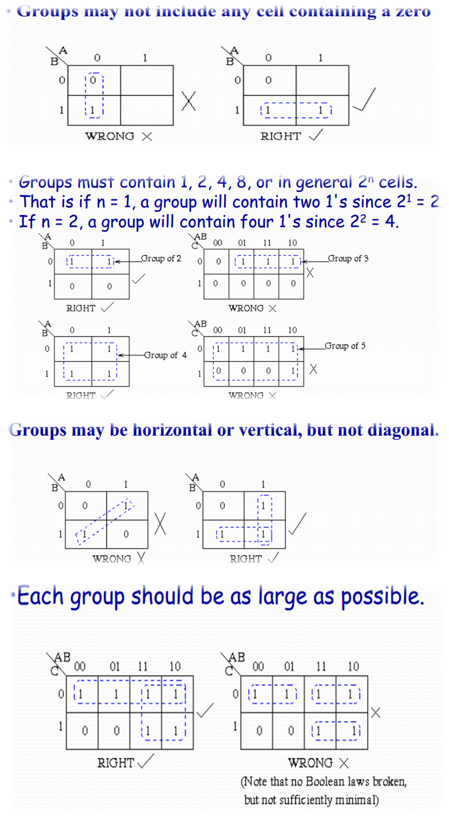

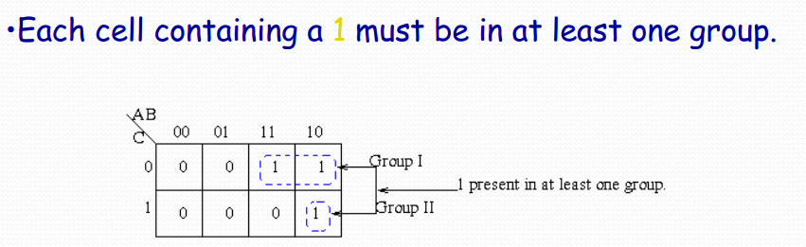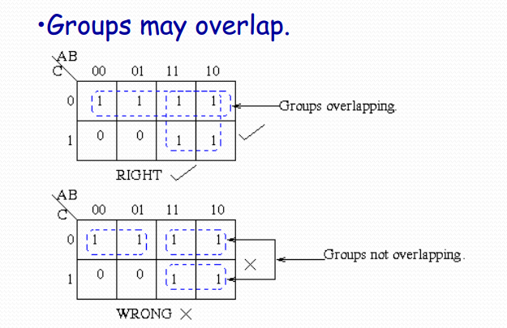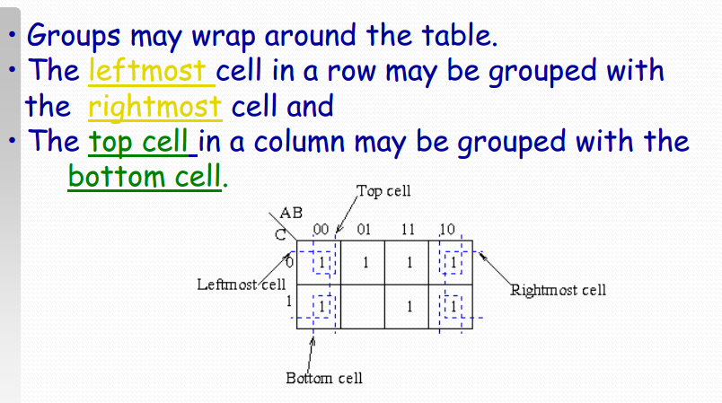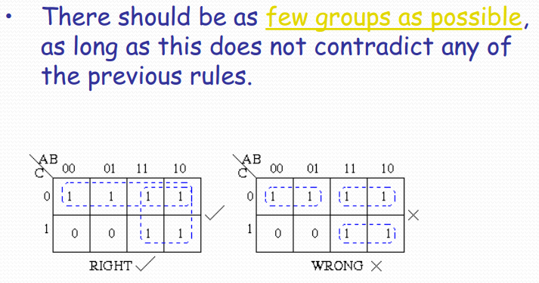

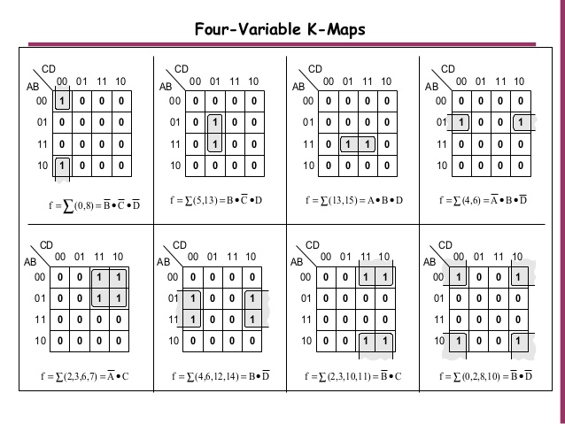

# Lab Task

